# LED (Light Emitting Diode) An LED is a semiconductor light source that emits light when current flows through it. Unlike traditional bulbs, LEDs don’t have filaments—they rely on electroluminescence.

**Working Principle:**  
When a suitable forward voltage is applied, electrons move through the semiconductor material and recombine with electron holes. This process releases energy in the form of photons (light). Polarity matters: the long leg (anode) connects to the positive, and the short leg (cathode) connects to the negative.

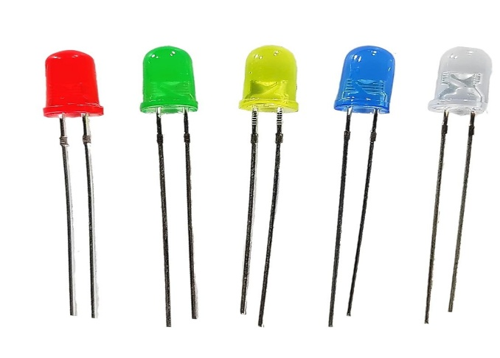**Types:**  
- Standard LED  
- Bi-color / Tri-color LED  
- RGB LED  
- SMD LED  
- High-Power LED

**Applications:**  
- Power indicators  
- Digital displays  
- Decorative lighting  
- Remote controls  
- Backlighting in devices

**Advantages**:  
- Energy-efficient  
- Long lifespan  
- No warm-up time  
- Safe (low voltage)  
- Available in many colors and sizes

**Disadvantages**:  
- Directional light  
- Needs current-limiting resistors  
- Sensitive to heat and overvoltage